

COVID VIOLATION

DETECTION

## Final Year Project Report

**Group Member 1: Uzair Ahmed (61842)**

**Group Member 2: Abdul Qayyum (60809)**

Under the Supervision of

**Umair Qureshi**

Department of Computer Science

-

**2021 - 2022**

# ABSTRACT

One of the most common issues of COVID-19 is its deadly spreading nature. Many people were infected of this virus due to contact with each other without knowing who is infected. It is a very difficult challenge to separate infected people from healthy people, especially in large places.

Moreover, manually monitoring people for COVID SOP guidelines by a single individual is a difficult task and also there is a high risk of that person getting infected, so, to overcome these problems we created ‘COVID Violation Detection’ project.

We have implemented face mask, distance maintaining and fever detection system in our project, for which an (IP) camera, artificial intelligence, machine learning algorithm, video processing and creating of dataset are accoutered. Through this project the management is also alerted that among the crowd which people are following SOP guidelines and which are not so they can take good measures to make safety necessary, in order to protect people’s lives. To minimize COVID spread, fever detector will help in finding out who has COVID to separate those infected people from healthy individuals and bring them to quarantine as early as possible.

This project is not limited to COVID only, as it can be revolutionary in medical sciences and security fields by making use of its human detection,

distance maintaining and body temperature detection features.

## ACKNOWLEDGEMENT

***In the name of Allah, the most Gracious and the Most Merciful. Peace and blessing of Allah be upon Prophet Muhammad* ﷺ**

First, praise of Allah, for giving us this opportunity, the strength and the patience to complete our FYP finally, after the challenges and difficulties. We would like to thank our supervisor **Sir Umair Qureshi** for his guidance, motivation and most his significant contribution in this project, expert **Miss Hira Beenish**, **Sir Farooq**, and **Sir Abuzer Zafar** for giving us the opportunity to work on this project. We would also like to thanks our parents for their financial and moral support and our friends who have helped and motivated us throughout. May Allah reward them all abundantly Ameen.

## DEDICATION

This report is dedicated to PAF-KIET University, our teacher, and our Supervisor, our Parents, our fellow colleagues and the hard-working students of PAF-KIET, with a hope that they will succeed in every aspect of their Academic Career and this project may help them in any aspect of their life.

## TABLE OF CONTENTS

**Titlepage.......................................................................................................1**

ABSTRACT 2

ACKNOWLEDGEMENT 3

DEDICATION 4

TABLE OF CONTENTS 5

CHAPTER 1 8

1. Introduction 8
   1. Motivations 8
   2. Problem Statement 8
   3. Objectives and Contributions 9
   4. Project Scope 9
   5. Organization of the Report 9

CHAPTER 2 10

1. Literature Review/Process Review 10
   1. Introduction 10
   2. Literature Review 13
   3. Functional and Non-Functional Requirements 13
   4. Project Significance 14
   5. Software Platform 14
   6. Scalability 14
   7. Services 15

CHAPTER 3 16

1. Projects diagrams 16
   1. Use Case Diagram 16
   2. Activity diagram 17
   3. System Block Diagram 18
   4. System Architecture 19
   5. ER Diagram 20
      1. Flow Diagram 21
   6. Inside Project 22
   7. Diagrams 23

CHAPTER 4 24

1. Project Planning 24
   1. Project Timeline Summary 24
   2. Project Timeline Details 24

4.3 Black-box Testing 25

4.4. Test Cases 26

CHAPTER 5 29

1. GUI OF PROJECT 29
   1. Sign-in Interface 29
   2. Detection Interface 29
   3. Mask Detection 30
   4. Distance Detection Interface 31
   5. Heat detection Interface 31
   6. Temperature Detection Interface 32
   7. Push Bullet Interface 32

CHAPTER 6 33

1. Conclusion and Future Work 33
   1. Limitation 33
   2. Conclusion 33
   3. Future Works 33-34
   4. Project Code 35-43
   5. References……………………………………………………..44

**LIST OF FIGURES**

|  |  |  |  |
| --- | --- | --- | --- |
| **S.NO** | **Figure No.** | **Figure Name** | **Page No.** |
| **1** | **Figure 3.1** | **Use Case Diagram** | **16** |
| **2** | **Figure 3.2** | **Activity Diagram** | **17** |
| **3** | **Figure 3.3** | **System Block Diagram** | **18** |
| **4** | **Figure 3.4** | **System Architecture** | **19** |
| **5** | **Figure 3.5** | **ER Diagram** | **20** |
| **6** | **Figure 3.5.1** | **Flow Diagram** | **21** |
| **7** | **Figure 5.1** | **Sign In** | **29** |
| **8** | **Figure 5.2** | **Detection Interface** | **29** |
| **9** | **Figure 5.3** | **Mask Detection** | **30** |
| **10** | **Figure 5.4** | **Distance Detection Interface** | **31** |
| **11** | **Figure 5.5** | **Heat Detection Interface** | **31** |
| **12** | **Figure 5.6** | **Temperature Detection Interface** | **32** |
| **13** | **Figure 5.7** | **Push bullet Interface** | **32** |

**CHAPTER 1**

## Introduction

In this COVID violation detection project, we are using python language, machine learning, artificial intelligence, and IoT.

Manually checking entire masses individually for COVID SOP and separating infected people is tedious. To cater to this problem, we have built this project to help educational institutions, medical hospitals, malls, and offices quickly implement SOP guidelines for people. Our project will have an IP Camera to help with real-time detection, identification, and alarm management about people not following SOP guidelines.

## Motivations

As the Coronavirus wreaks havoc in the world, we need to think about a solution to stop the spread of Coronavirus among the masses to protect everyone's life.

## Problem Statement

As the virus became a pandemic, many people started getting infected, so preventive measures must be taken seriously. It wasn't easy to distinguish people who have COVID from those who do not. Hiring people to check for symptoms of COVID in public areas such as hospitals, offices, schools, and malls were challenging, and their risk of becoming infected was very high.

## Objectives and Contributions

Our main objective is to contribute to medical sciences and bring technology to Pakistan to help with disease detection and prevention at an early age.

Our scope for this project is for COVID detection and violation. In this, we will help save people by separating COVID-infected people from healthy people to save as many lives as possible and keeping infected people by early detection and taking them to hospitals for recovery.

Our contributions are to educate people about the Coronavirus SOPs and their deadly spreading nature and make it possible to save people from infections.

## Project Scope

The project scope is to detect COVID violations & their patients using IoT, Security, and Computer Vision to make a more efficient system by using techniques to be solved.

## Organization of the Report

The report is written to demonstrate the structure, the process it went through, and for what purpose it exists. We have written this report to give everyone a good idea of the product.

## CHAPTER 2i

## Literature Review/Process Review

## Introduction

In this literature we will talk about image classification,deep learning convention methods and using appropriate algorithms.

## Image classification

The classification of image is achieved by differentiating to image based of vision of content. Image classification is used for Artificial Intelligence for detecting anything or differentiate between two products or differentitate the two similar products.

The image classification mainly use conventional methods. Machine learning usually use image classification method for identification and machine learning process.

Limitation of machine learning is it can only extract certain points set of the features on the picture and unable to extract from dataset of differentitating feature this drawback correct by deep learning algorithm.

The identification of image feature of deep learning that is the neural networks to

Differentiate between two images.The integrated model able to learn to differentiate into images.The accuracy level of differentiating two images depend upon the dataset.

.

## Algorithms Used Yolo Algorithm Benefits

Yolo algorithm is used for identification differenciation,on realtime with good accuray.Yolo algorithm provides bounding boxes for detection.

CNN tells bounding boxes simulataneously in yolo it trains on images wide area to increase detection performance. Advantages of YOLO are object detection.

Following are the advantages:

* YOLO do encoding of information as their appearance.
* YOLO work on natural photos for best performance in detecting and identification.
* YOLO is most fastest algorithm.

## Computer Vision

Computer Vision understand images,videos, how stored and manipulate data. CV used for AI mostly. CV is playing major roles in Tesla car, new AI inventions,

**OpenCV**

OpenCV is a library used in computer vision, machine learning(ML), and image processing, and now it plays role in real-time operation. It very important in new version systems.Using OpenCV we can process images and videos to identify objects, faces, or even handwriting of a human. It is integrated with various libraries such as NUMPY is use to processing the OpenCV array structure for analysis. Image pattern and its various features we use vectori spacei and perform mathematical/logical operations on theseicharacteristic.

## Kerasi

Keras (K) is a API of deep learning written ini Python (PIP) programming.

Keras isi:

•Simple -- Keras reduces developer perceptive load to free individuals to focus on problems.

•Flexible -- Keras take on the Fundamental of progressive expose of complexity ,easy workflows shouldi beifast.

## TensorFlowi

TensorFlowi is an machine learning framework, take out highend- performance numericali computations. TensorFlow providesiclear architectural support, allowsi deploymenti of computations across a variety of platforms from desktops to collection of servers/databasei andi corner-pointi devices.

Tensor Flow gives a set of workflows to develop & models training using Python or JavaScript, andi toi deployi ini cloudi, on-prem, in the browser, or on-device. The tf. Data API enablesi you to buildi complexi input pipelines from reusable pieces.

Tensor flow is usefull than OpenCVi for somei use cases andi OpenCV is usefull than Tensor flow in some other use cases. Tensor flow's place of strength are in the training/awareness side. OpenCV's points of strengthi are in the deploymenti side.

## Literature Review

Literature review for COVID violation detection project.

## Functionali and Non-Functionali Requirementsi

* + - * 1. **Functional Requirementsi**
* Configuration of camera
* Use open-cv for mask detection
* Use open-cv for distance detection
* Infra-red sensor/camera for fever detection
* Implement algorithm for detection of the mask and SOP distance
* Push bullet alert system

## Non-Functional Requirements

Use of high-end pc

Use of more Ip cameras

## Project Significance

This project will help in identifying and separating COVID p

erson (infected) from uninfected people and saving people's lives.

## Software Platform

* + - Python language
    - React
    - Machine learning algorithm
    - Visual studio code
    - Web application
    - Arduino IDE

## Scalability

It is necessary for us to use python libraries in the python language as it can deal with models of machine learning ,keras,open cv,computer vision techniques efficiently.Mobile net is used as a foundation of architecture it has high and low power for computations and for scenarios the algorithm we are using in our covid violation project is CNN(Convolutional Neural Network).

## Services

We have implemented four of the modules for the following

* **Face mask and Distance Detection.**
  + Our project can identify people with preprocessing of the image it also detects people in live video and if peoples are wearing mask and following distance than it will show no violations occurs,but if people goes against sop guidelines and not wearing mask and following distance then violation occurs will be seen on screen.and buzzer sound will give to remind people to carry sop guideline strictly so virus prevention occurs.
* **Collection of dataset from people.**
  + We have collected data’s of people that are wearing mask or not and also there distance how far are they from each other.high success ratio depends on the numbers of distances and mask images of with mask and without mask we acquired.
* **Data Extraction from people.**
  + We have extracted data of facial features in different lighting for image and also extracted data of distance between 2 people and calculated their distance of 6 feet apart from each other.
* **Models Training.**
  + In our project we have train the model with keras,Computer vision,deep learning,machine learning,Artificial intelligence and with python library.

# CHAPTER 3

## Projects diagrams

Diagrams of our project.

## Use Case Diagram

## It shows the working of the face detection module.

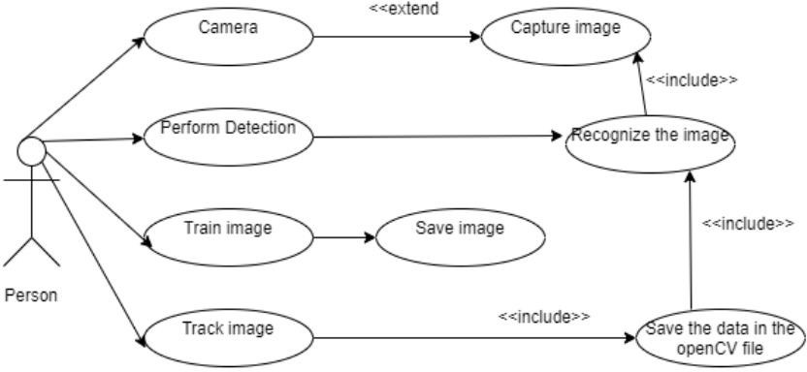

## Activity diagram

## It shows the algorithm of image detection.

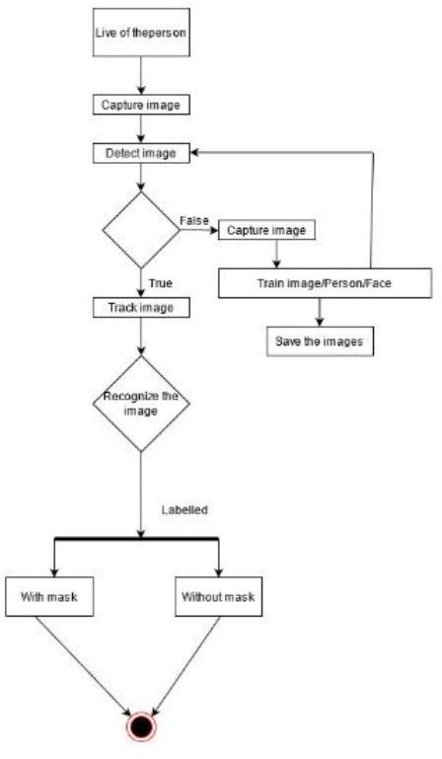

* 1. **System Block Diagram**

This block diagram shows the detection of face and show green boxes on the detected faces.

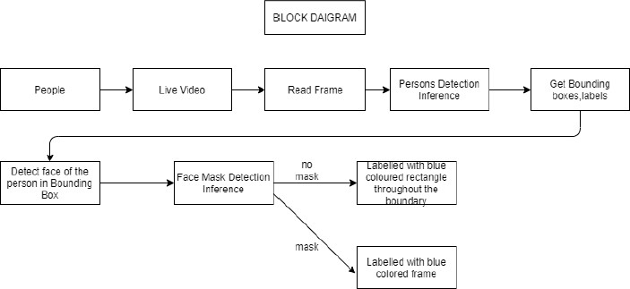

* 1. **System Architecture**

This architecture shows the data gathering and process.

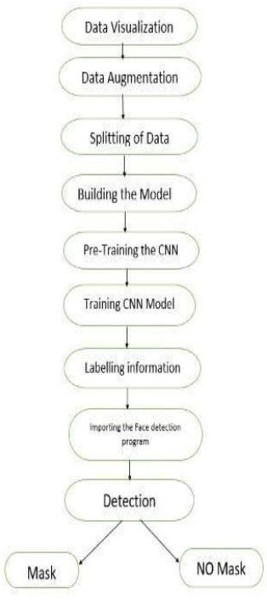

* 1. **ER Diagram**

This diagram shows the working of yolo algorithm.

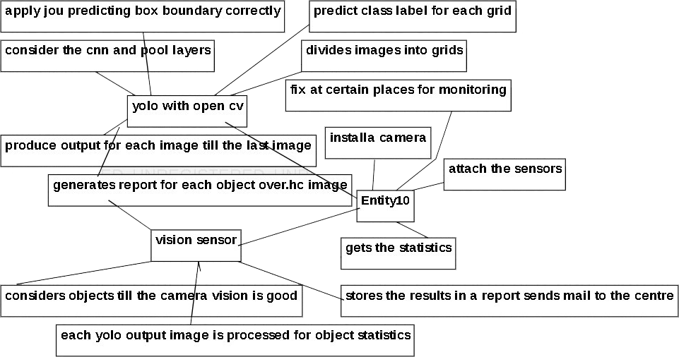

## 3.5.1 Flow Diagram

## This flow diagram shows how the algorithm distinguishes between people who are wearing and people who are not wearing the mask.

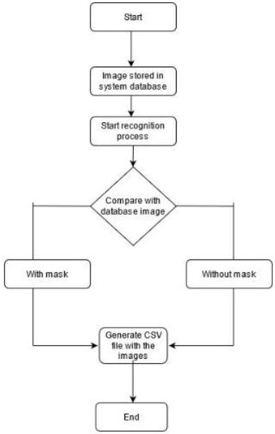

* 1. **Inside Project**

Node MCU

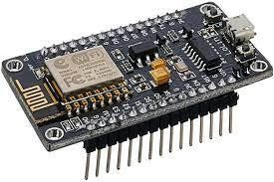

Node mcu is lua built firmware.it also has development board it is mainly used for IOT built Applications.It is powered by Micro usb jack also with vin which is an addition supply pin.With node mcu you can have 128 kb of ram and also 4 mb flash space for storage of data and programs.It also supports uart,12c and spi of the interface.the node mcu we are using is esp8266 it got esp-12e module.it has build in wifis and Bluetooth with deep sleep operating characteristic perfect for iot projects.

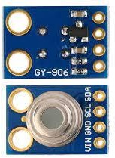The mlx90614 is infrared thermometer(heatdetector) it can detect without touching the skin. It is used for temperature measurement.it has application like body temperature,suface of heating detection of temperature,detection of contactless temperature detection.it has IR sensitive thermopile detector chip and also signal conditioning asic,both are are added to the TO-39.its has -40 to 85 centigrade ambient temperature it also has from -70 to 382.2 centrigrade target temperature.

## Diagrams

## This diagram shows training face mask and applying the face mask detection, and showing the open cv social distancing detection steps.

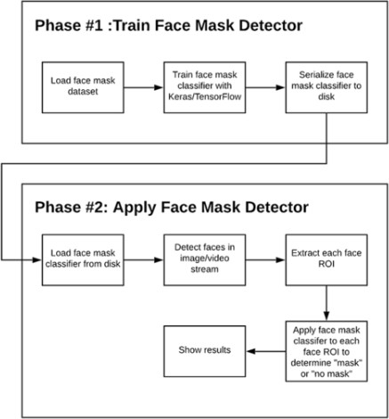

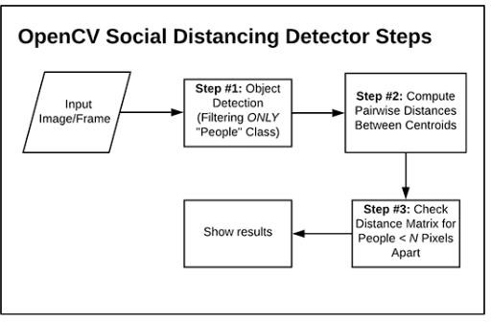

# CHAPTER 4

## Project Planning

We have planned our project according to the following timeline:

## Project Timeline Summary

First, we proposed & implemented a mockup of the project, and then we started web application development and face mask detection implementation. After that, social distance maintenance, fever, and heat detection algorithm coding were started. We bought a hardware IP camera, node MCU to use to detect faces, social distance maintaining, and for fever/heat detection.

## Project Timeline Details

* 25th Oct mockup
* 6 Nov 2021 Configuration of the camera
* Task:
  + 1. Configuration of a normal camera for mask detection
    2. Configuration of IR Camera (camera having heat sensor) for fever detection
    3. Configuration of the normal camera for sop distance maintain identifier
* 20 Nov 2021 Identification of people wearing masks and sops
* 4th Dec 2021Face mask identifier and Sop distance maintain identifier.
* 1st Jan 2022 Front end of the application web application
* 5 Mar 2022 buying the hardware IP camera, node mcu, mlx90614.
* 19th march 2022 Configuration of 3 camera software install inside it and mlx heat detection sensor will be implement.
* 14th may final report complete and Mobile will get a Alert System using push bullet as well as web application using also get push bullet.

## Black-box Testingi

Black box testing is also labeled as behavioral testing,it is a consumer testing product, the internal formation/scheme/implementation of the tried things is hidden to analyser.the tests may be fruitless or practical,furthermore pratical testing either fruitless or practical without instance of the within design of the detail or skeleton.

The method is to use a strategy for infer and additionally choose tests conditional on inspection of particulars,choosing between fruitless and practical of segment or structure with no reference of the internal skeleton.

Discovery examine faces is pertinent to go with degrees of programmable examine:

* String of the testing/Integration of the test
* Sytem level of the test
* Receipt testing

The bigger level, consequently of greater furthermore mind boggling case, discovery examining technique involve into utilization.

## System Testingi

We tested our web application on an emulator and smartphone that the functionalities in the application is performed accurately.

## Integration Testing

Authentication login for users. Proper instruction sending from command prompt to web application for starting of the web application.

## Unit Testing

* + - * Sign up
      * Login

## 4.4. Test Cases

The Test Cases is a bunch of definitions to provide us platform for the use of analyzation of running project with different techniques. The techniques and method of testing provide us to do testing over our project modules interaction connection and all of the basics intends.

## TEST CASE # 1

**Test Case Title: Login**

|  |  |
| --- | --- |
| Preconditions | Login with authenticity/Valid user  account |
| Actions | Enter correct Login details and hit login button |
| Expected Results | Login Successful |
| Tested By | Abdul Qayyum/Uzair Ahmed |
| Result | Pass/Fail |

**TEST CASE # 2**

**Test Case Title: Sign Up for New User**

|  |  |
| --- | --- |
| Preconditions | Fill all data required to sign up according to boxes given |
| Actions | Fill all data required to sign up according to boxes given and then hit Sign Up button |
| Expected Results | Registration Successful |

|  |  |
| --- | --- |
| Tested By | Uzair Ahmed/Abdul Qayyum |
| Result | Pass/Fail |

**TEST CASE # 3h**

**Test Case Title: Temperature Detection Node Mcu and Mlx90614**

|  |  |
| --- | --- |
| Preconditions | Send data to Node MCU and MLX90614 on key command |
| Actions | Select Node Mcu and Mlx90614 and connect it to web application and then run the command, place it on Finger to  check the temperature of the person |
| Expected Results | Body Temperature View |
| Tested By | Abdul Qayyum/Uzair Ahmed |
| Result | Pass |

**TEST CASE # 4h**

**Test Case Title: Mask Detection**

|  |  |
| --- | --- |
| Preconditions | After we click button on mask detection. Mask detection screen popup and bounding box become green when mask is put on and become red if we put off the mask. It also shows accuracy in percentage. |
| Actions | The Yolo algorithm detects the face on the screen and compare it to dataset after that the bounding box screen become green when we put mask on and it becomes red if we put off the mask.at the same time it shows  percentage of accuracy |
| Expected Results | Face Is Detected. |
| Tested By | Uzair Ahmed/Abdul Qayyum |

|  |  |
| --- | --- |
| Result | Pass |

**TEST CASE # 5h**

**Test Case Title: Social Distance Detection**

|  |  |
| --- | --- |
| Preconditions | After we click button on distance detection. Distance detection screen popup and bounding box become green when distance is maintained and becomes red if people come close to each other, violating sop guidelines. It  also shows accuracy in percentage. |
| Actions | The Yolo object detection algorithm detects the social distance maintaining, after that the bounding box becomes green when people maintain distance it becomes red if they are close to each other. It also  shows accuracy in percentage |
| Expected Results | Distance Maintain Detected |
| Tested By | Uzair Ahmed /Abdul Qayyum |
| Result | Pass |

**CHAPTER 5**

## GUI OF PROJECT

## Sign-in Interface

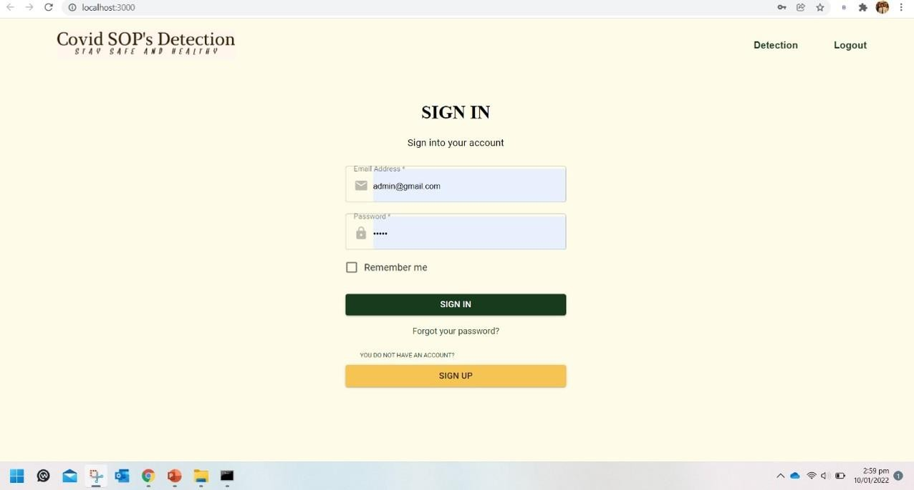

## Detection Interface

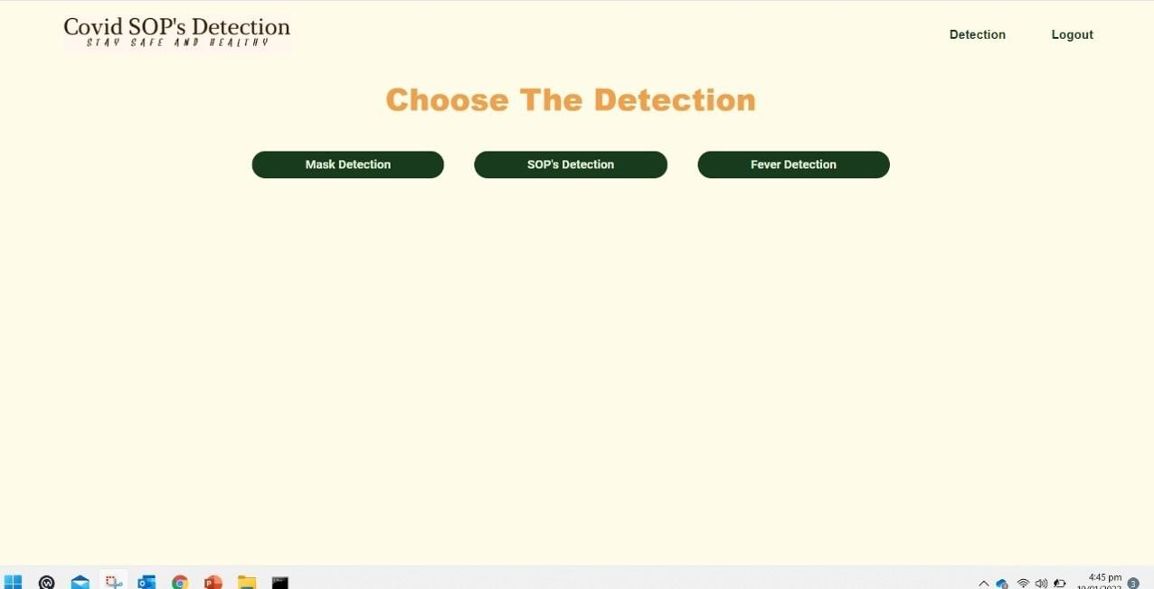

## Mask Detection

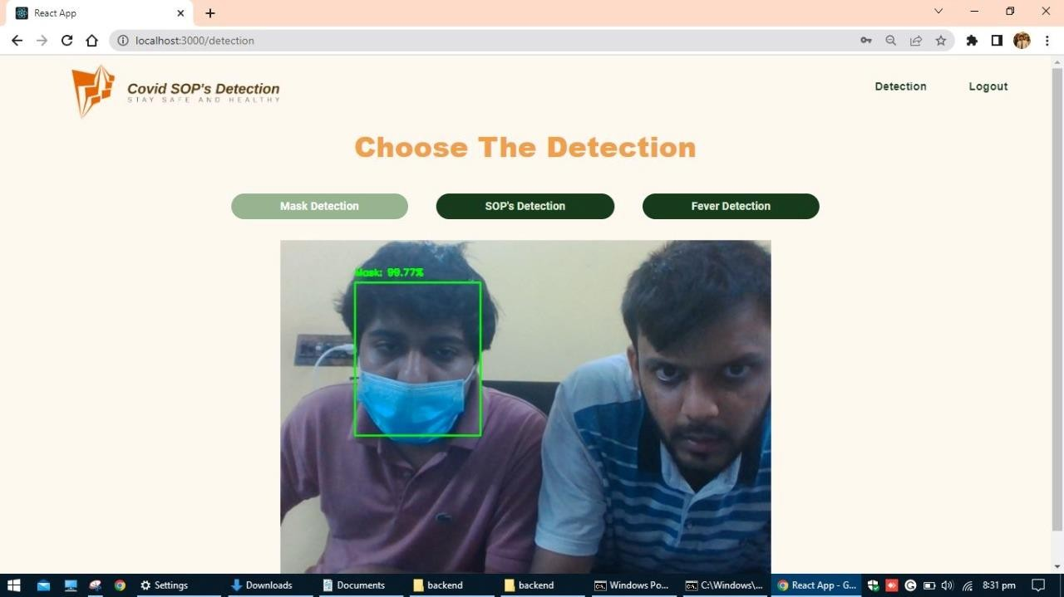

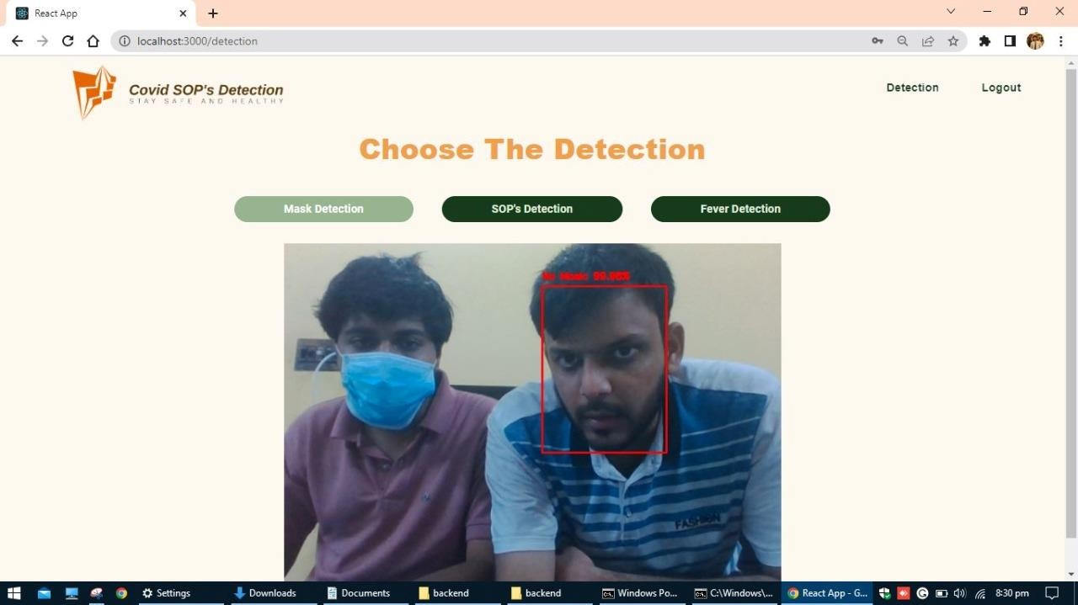

* 1. **Distance Detection Interface**

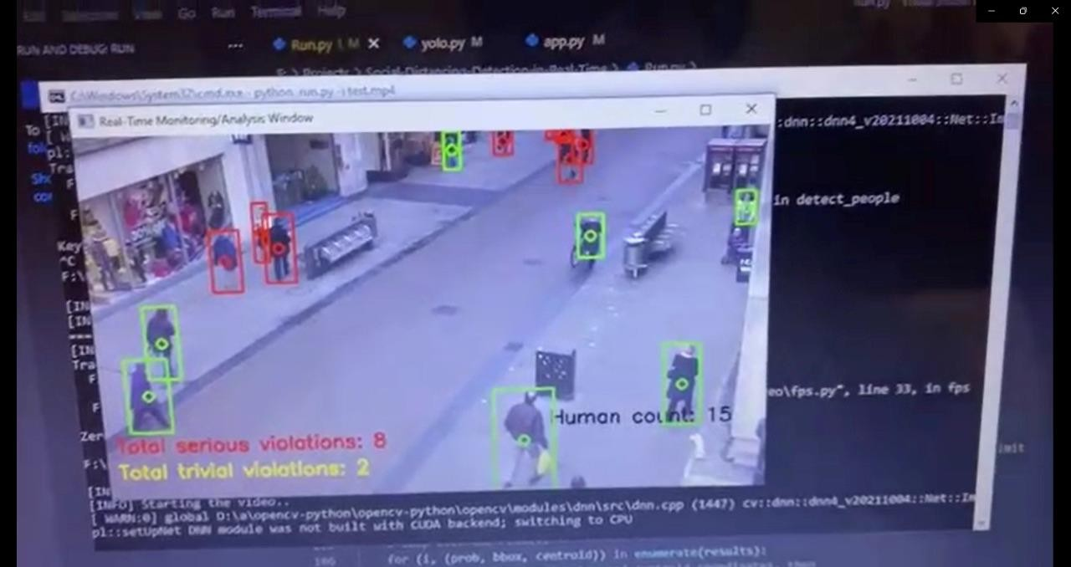

* 1. **Heat detection Interface**

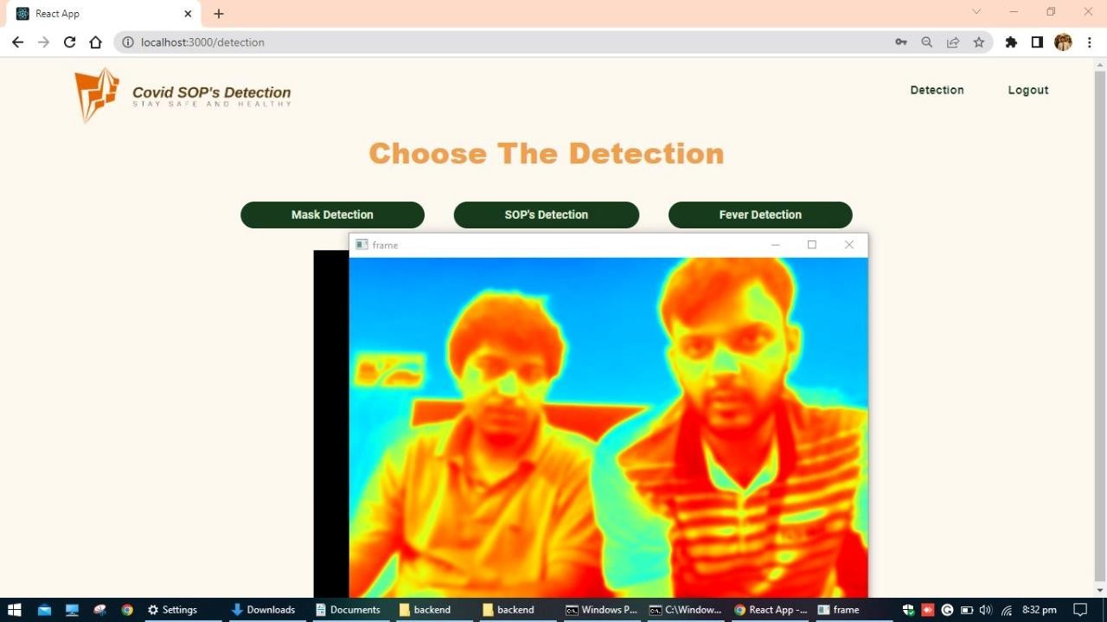

* 1. **Temperature Detection Interface**

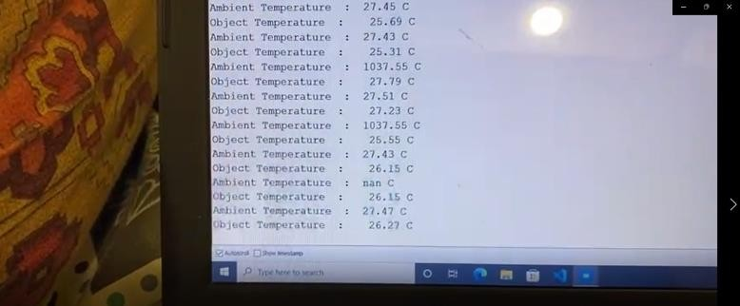

* 1. **Push Bullet Interface**

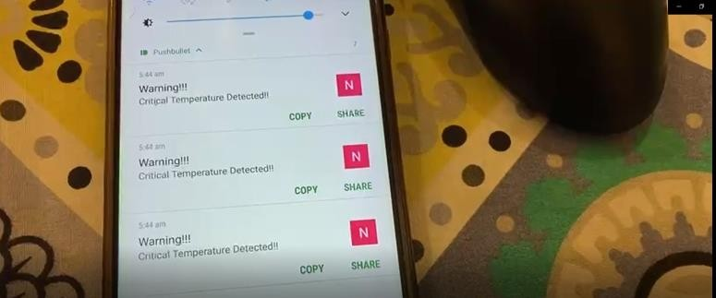

**CHAPTER 6**

## Conclusion and Future Work

The details of our project limitation, conclusion and future work are given as below:

## Limitation

* This project requires electricity to work.
* Our scope is limited to work for COVID violation but can be implemented in various areas of medical sciences and security.
* This project needs good quality camera.

## Conclusioni

In conclusion, we have created a web-based application system, allows the users (management) to check the detection of COVID in peoples, checking there mask detection, distance detection, fever detection and heat detection. In this project we have used yolo algorithm for object detection. The project uses AI (Artificial Intelligence) to determine whether sop guidelines is being followed by individuals or not and alert notification will be notified in mobile phones. This application will save many lives and bring awareness to people to maintain sop among themselves. The distance calculation is measured in 6 meter and it also show accuracy in percentage. The project is smart it can determine whether there are living being in live video or not. It makes bounding box among living beings and it also shows how many living beings are there and it does not make bounding box among non-living beings. The project also detect heat and fever, and if the temperature is high, the mobile is notified that person has covid. The application can be installed in school, malls, hospitals, offices and other places where there are many people come together.

## Future Works

This application has vast areas of implementation. It is not only designed for COVID but is also usable in the fields of medical science, security, sports and object detection.

Body temperature which we are detecting with the help of algorithms and IP camera is an essential parameteri for diagnosing fever . There is a definite correlation between body temperature and diseases. For example, with more resources we can scale our project to be used for Infrared Thermography noninvasive diagnosis of peripheral vascular diseases, heat gradients are observed in the affected regions of patients with vascular disorders, that indicate abnormal blood flow in the disaster region.

Our project, if highly scaled can be used to diagnose muscular sports injuries. Since muscle injuries trigger inflammatory processes and inflammation generates heat, the level of inflammation can be measured by evaluating the temperature gradient.

Furthermore, in security areas, human detection feature can used to implement a highly functional AI based security camera with other features including specific clothing detection, face features detection and so on.

This project has the potential to overcome many hurdles in various fields of Pakistan if adequate resources are provided.

In the future the web application can be converted to custom office monitoring system according to the need of the office or as per requirement.

Examples

* + 1. If the office having the policy not to eat or drink in office premises so we can customize this web application to the office policy.
    2. This project can also be customize and used as attendance system it can recognize face and mark the attendance of the employer in office or student in school or colleges.
    3. This project can also be used in hospital, checking fever and body temperature of individuals and doctor can give medicine according to the rise and fall in temperature of the person.
    4. This project can be used in cafeteria to detect who is eating and not paying the bill.
    5. This project can be used in store security purposes it will detect and save all the people faces which are coming in the store. If any stealing occur in the store and we can identify the thief.

## Project Code Node MCU

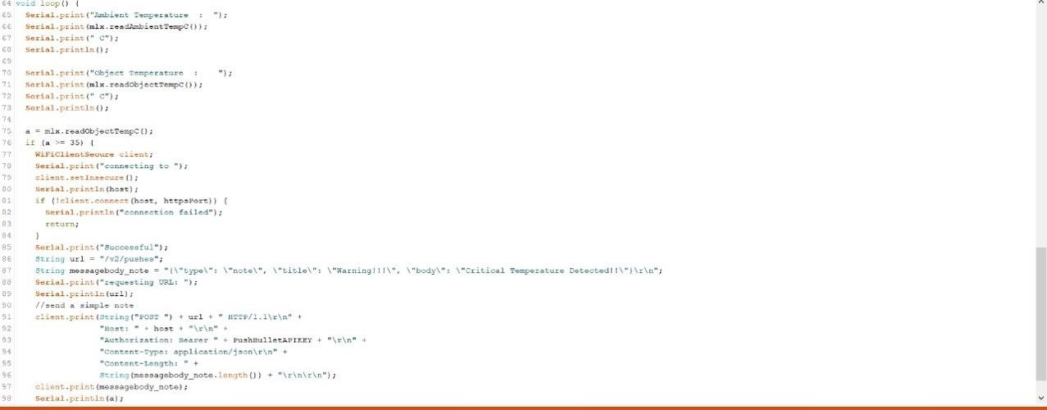

**Restnet Code**

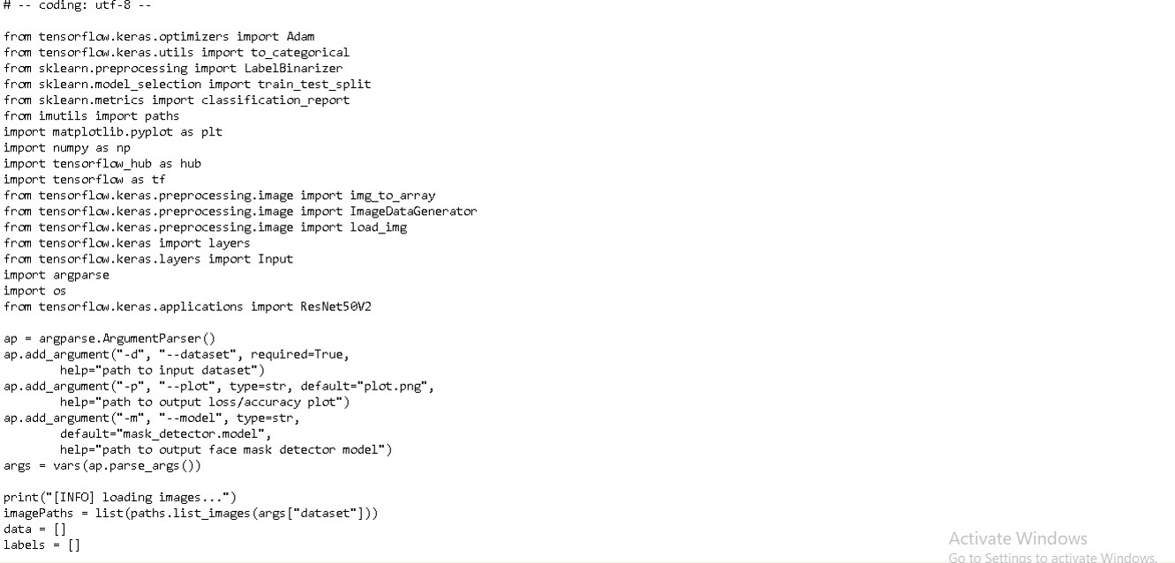

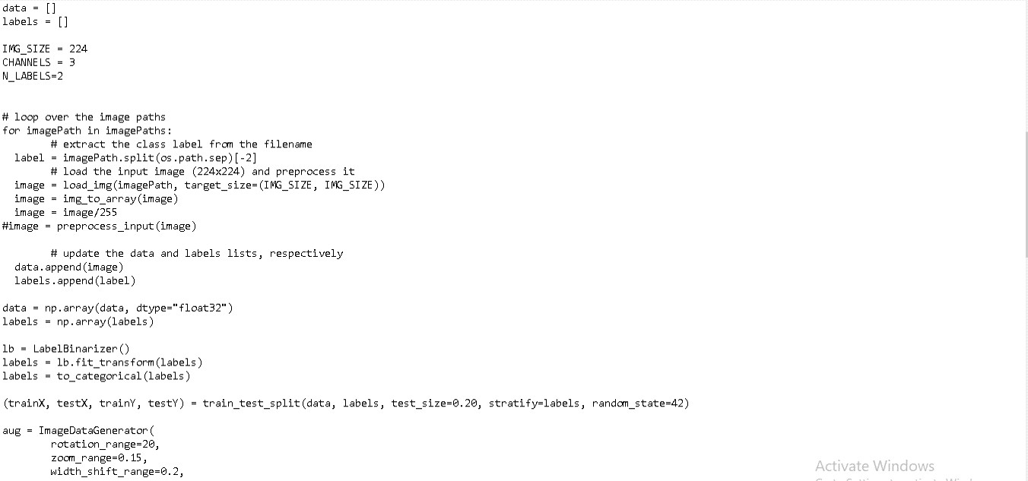

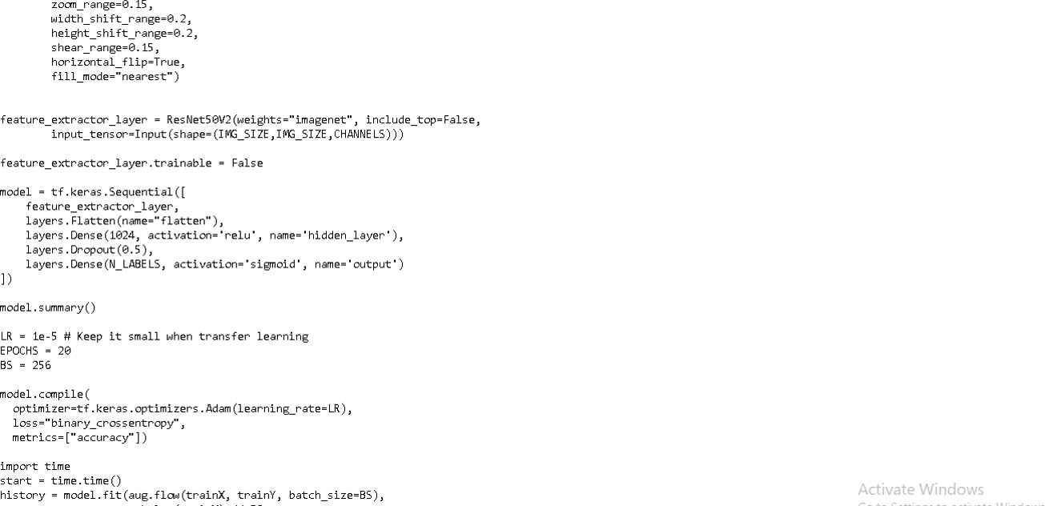

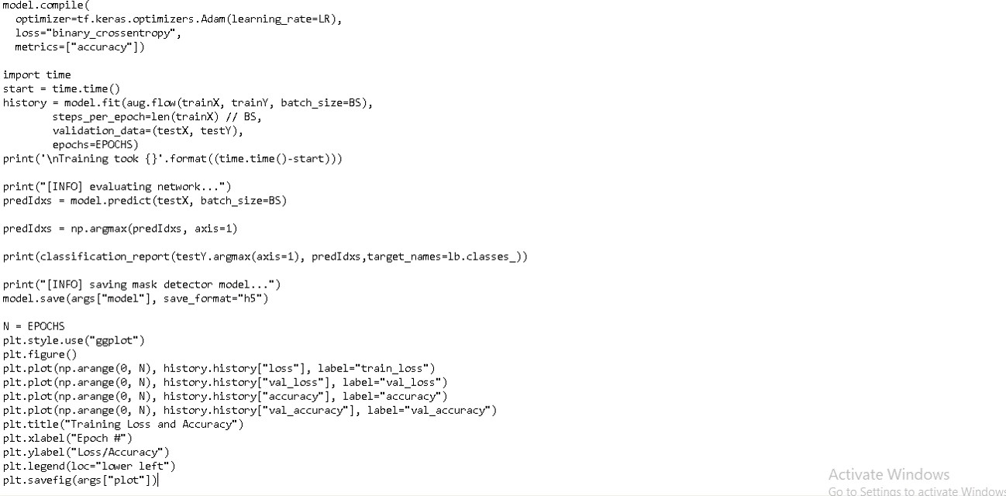

**Mask Detection Code**

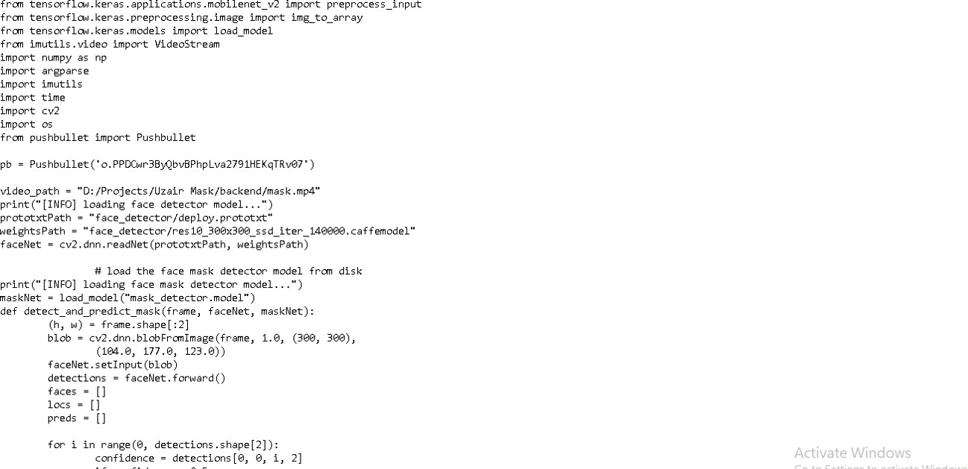

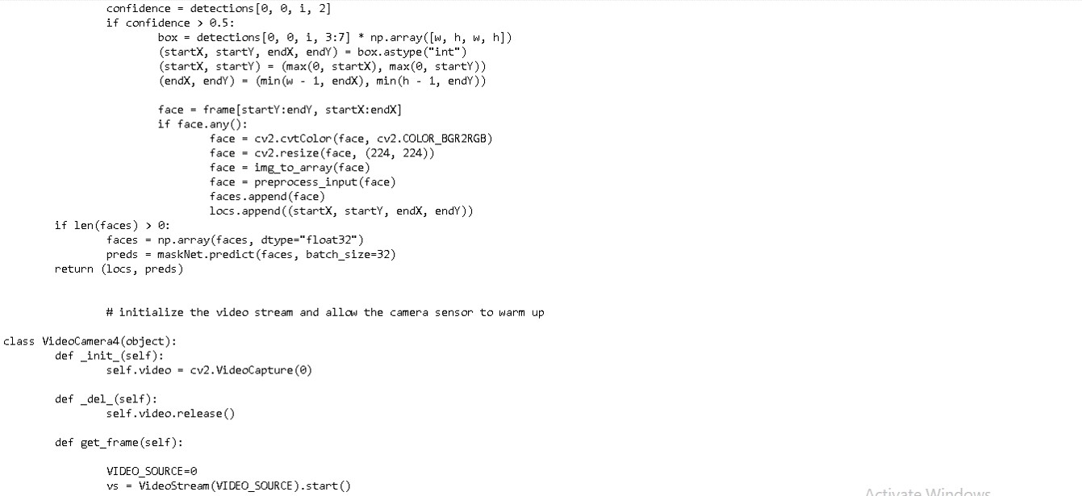

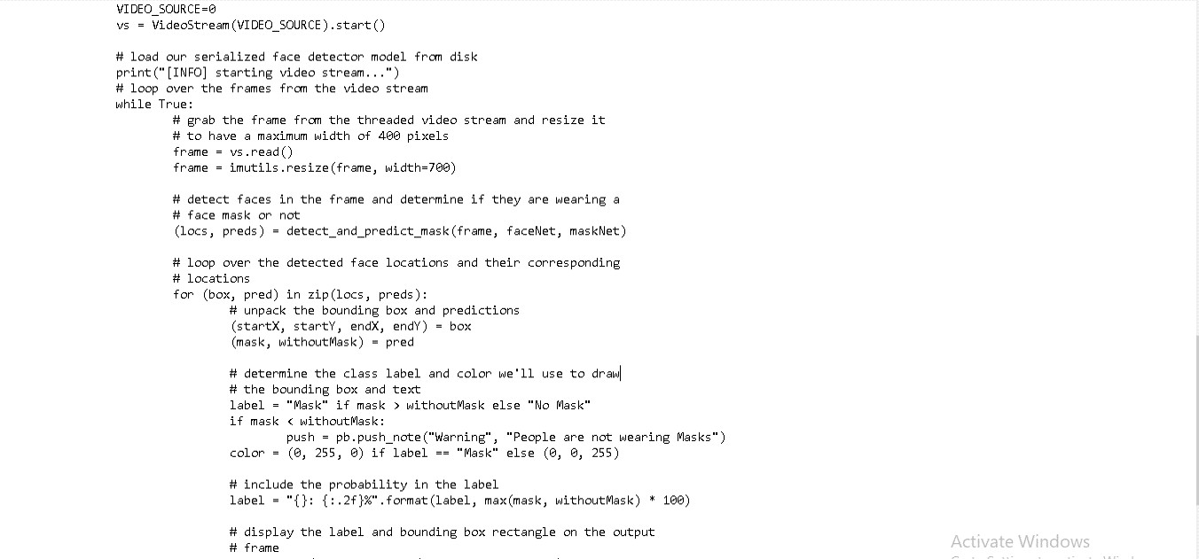

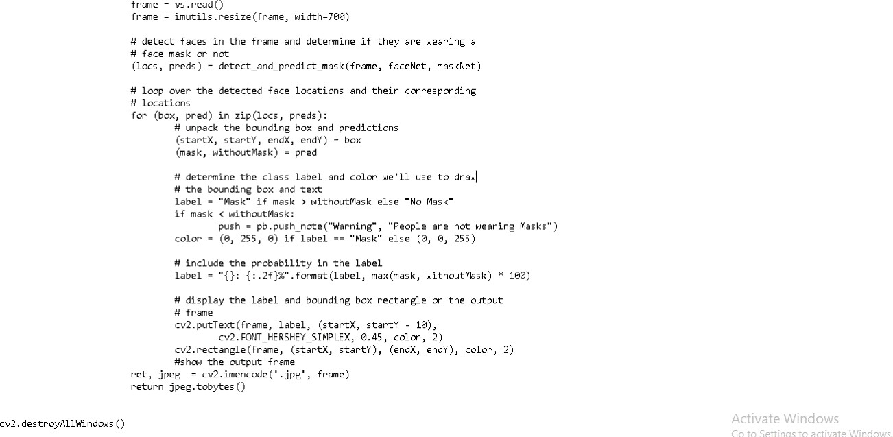

**Distance Detection**

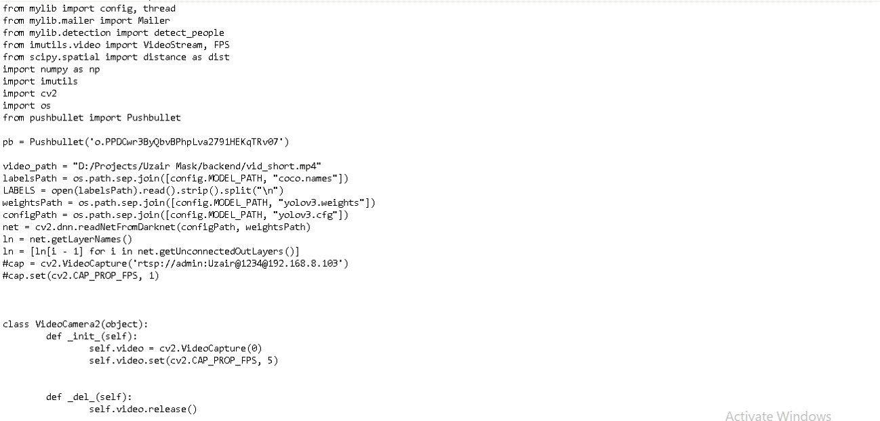

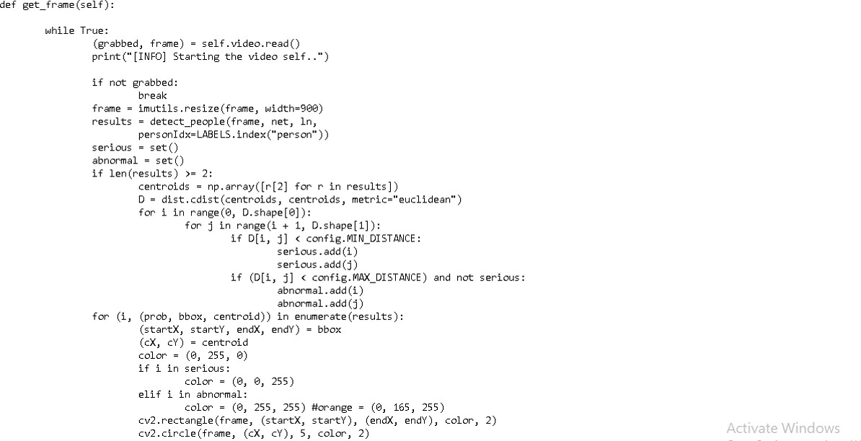

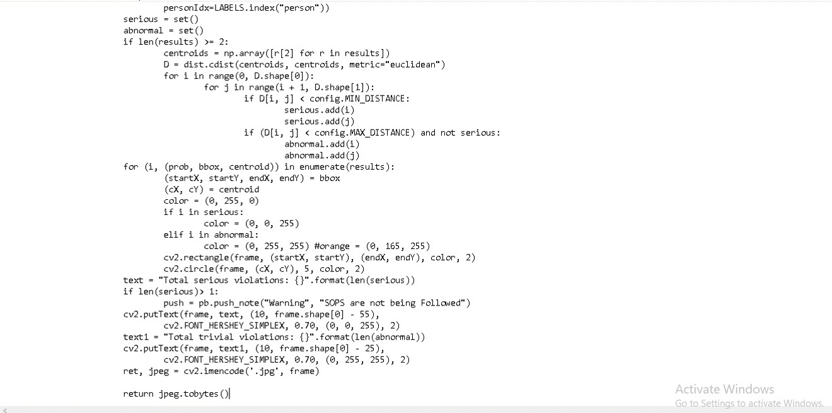

**Fever Detection**

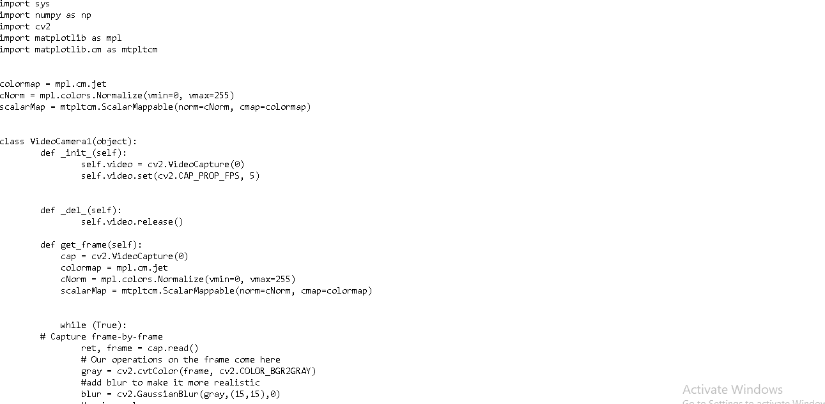

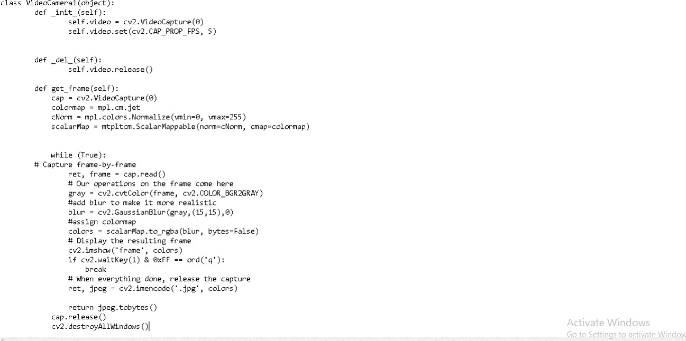

* 1. **Rerences**

[**https://components101.com/development-boards/nodemcu-esp8266-pinout-features-and-datasheet**](https://components101.com/development-boards/nodemcu-esp8266-pinout-features-and-datasheet)

[**https://www.melexis.com/en/product/MLX90614/Digital-Plug-Play-Infrared-Thermometer-TO-Can**](https://www.melexis.com/en/product/MLX90614/Digital-Plug-Play-Infrared-Thermometer-TO-Can)

[**https://electrobes.com/product/mlx90615-stm8s003f3p-contactless-ir-infrared-thermometer-sensor-module/#tab-more_seller_product**](https://electrobes.com/product/mlx90615-stm8s003f3p-contactless-ir-infrared-thermometer-sensor-module/#tab-more_seller_product)